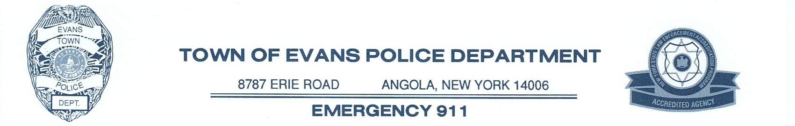
DOUGLAS J. CZORA 716-549-3600
Chief of Police FAX 716-549-6089

*** FOR IMMEDIATE RELEASE ***

December 17, 2018

The Town of Evans Police Department will be conducting a Citizen Police Academy beginning Thursday, January 31, 2019 and ending Thursday, March 21, 2019. The Citizen Police Academy has been designed as a way for the public to learn about police department operations and the duties of Evans Police Department personnel.

The academy will meet each week at 6:30 p.m., and classes will be approximately three hours. Some of the topics covered will include patrol functions, traffic enforcement, detective bureau operations, crime scene investigation, accident investigation, domestic violence, court procedures, police and fire dispatch operations, marine unit operations, and the function of the School Resource Officer.

Applicants must be at least 18 years of age, have never been arrested, be of good moral character, and pass a background check. Anyone interested in attending may pick up an application in person at the Town of Evans Police Station, 8787 Erie Rd., Angola, NY 14006, or online at www.evanspoliceny.com. Class size will be limited. Preference will be given to Town of Evans and Village of Angola residents and business owners. The deadline for submitting applications is Saturday, January 26, 2019.

Any questions may be directed to Ptlm. Joseph LaRosa at (716) 217-3500, ext 234, or email at jlarosa@evanspoliceny.com.

